**Machine Learning Model Deployment with IBM Cloud Watson Studio**

**Real-time Problem**

Predict the total score (runs) a team is likely to achieve in an IPL match based on factors such as venue, pitch conditions, team composition, and historical performance.

**Development Part 1**

IBM Cloud Watson Studio is a comprehensive platform designed to facilitate various aspects of data science and machine learning, from data preparation and analysis to model development, deployment, and collaboration. It's a part of IBM Cloud's AI and data science offerings and provides a unified environment for data scientists, analysts, and developers to work on their projects. Here's a more detailed explanation of IBM Cloud Watson Studio :

Automated Machine Learning with AutoAI:

* Watson Studio provides AutoAI, an automated machine learning tool that simplifies model development for users without extensive machine learning expertise.
* AutoAI automates feature engineering, model selection, and hyperparameter tuning to create high-performing machine learning models quickly.

Model Development and Training:

* Data scientists and machine learning engineers can build, train, and fine-tune machine learning models using various libraries, including scikit-learn, TensorFlow, and PyTorch.
* This platform supports both traditional machine learning and deep learning techniques.

Model Evaluation and Visualization:

* You can evaluate model performance with built-in metrics and visualization tools.
* Visualize model behavior and results to gain insights into model performance.

Model Deployment:

* Watson Studio integrates with Watson Machine Learning, allowing you to easily deploy your machine learning models as RESTful APIs.
* You can deploy models with a few clicks and configure runtime environments.

**AI Explainability:**

* The platform includes features to interpret and explain model predictions, enhancing transparency and trust in AI models.

**Integration with Other IBM Cloud Services:**

* Watson Studio seamlessly integrates with other IBM Cloud services, including data storage, databases, and cloud functions.

Now we are going to create the machine learning model with Watson Studio for that we will do the primary steps now :

**STEP1:**

* Login To The IBM account and click on the Catalog and then search for Watson Studio and give enter.
* You will get the Watson Assistant There By default you will have this

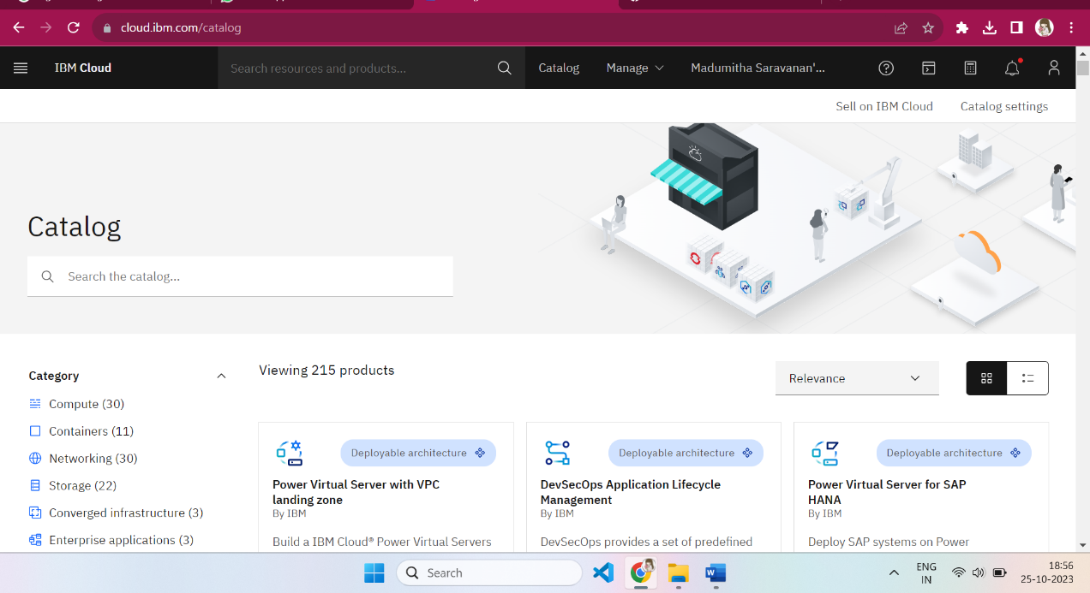

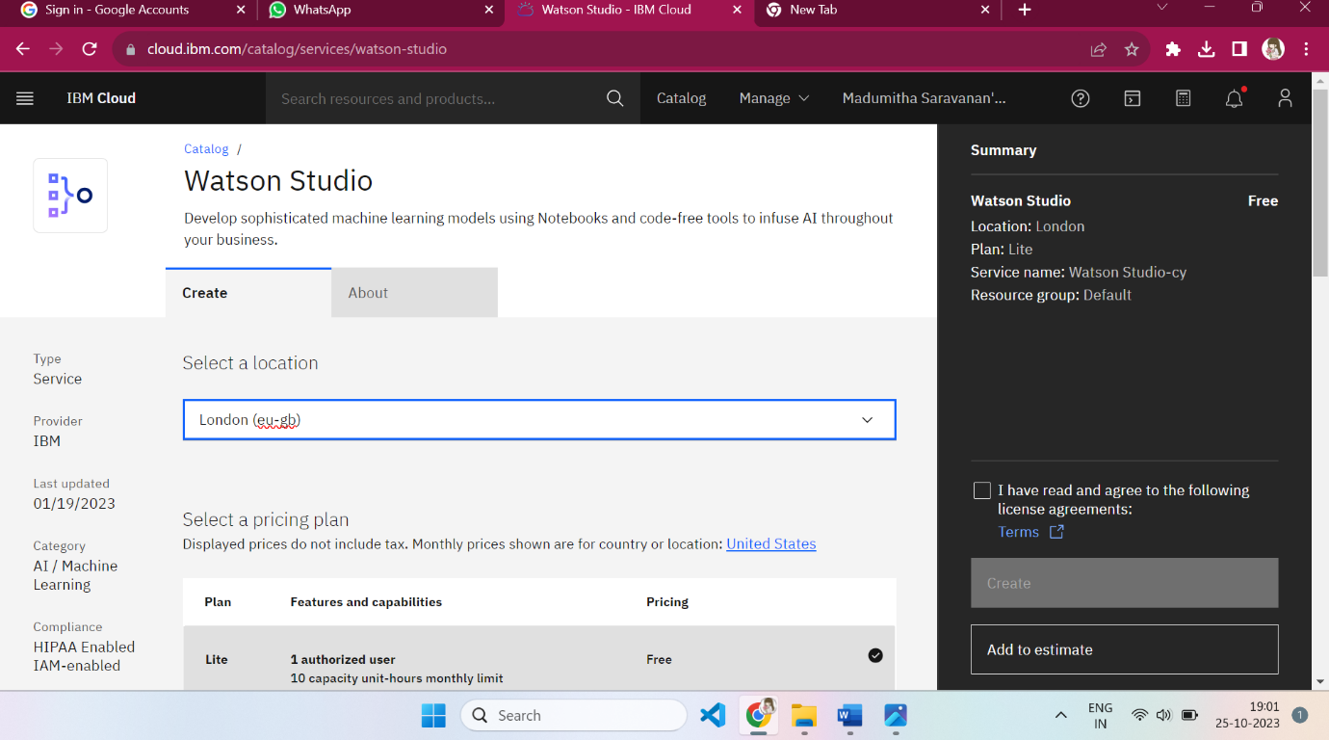

**STEP 2:**

* Change the default location and give the location as London(eu-gb) and select the plan as Lite
* Give tick mark for I Have read and agree to the following license agreement
* Now click on create it will create an instance for you

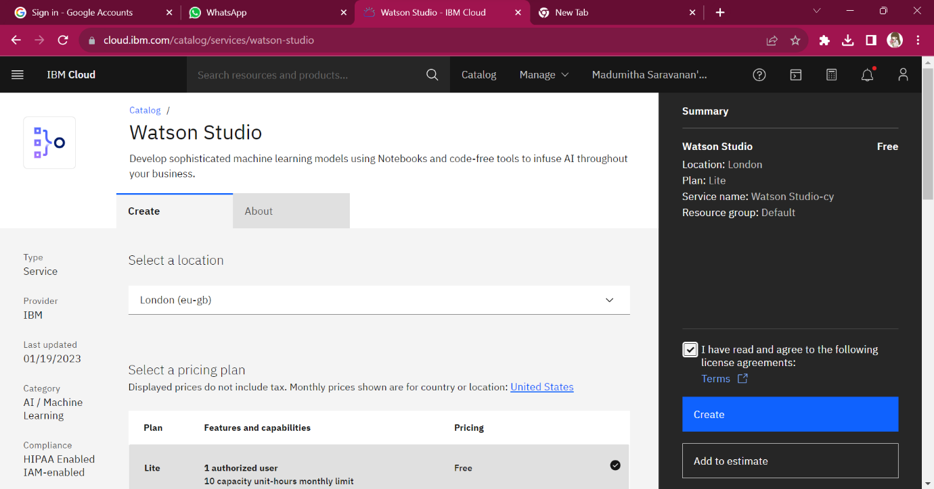Step 3 :

* After creating an instance for Watson Studio you need to launch the Watson Studio by clicking the launch the IBM Cloud Pak for Data

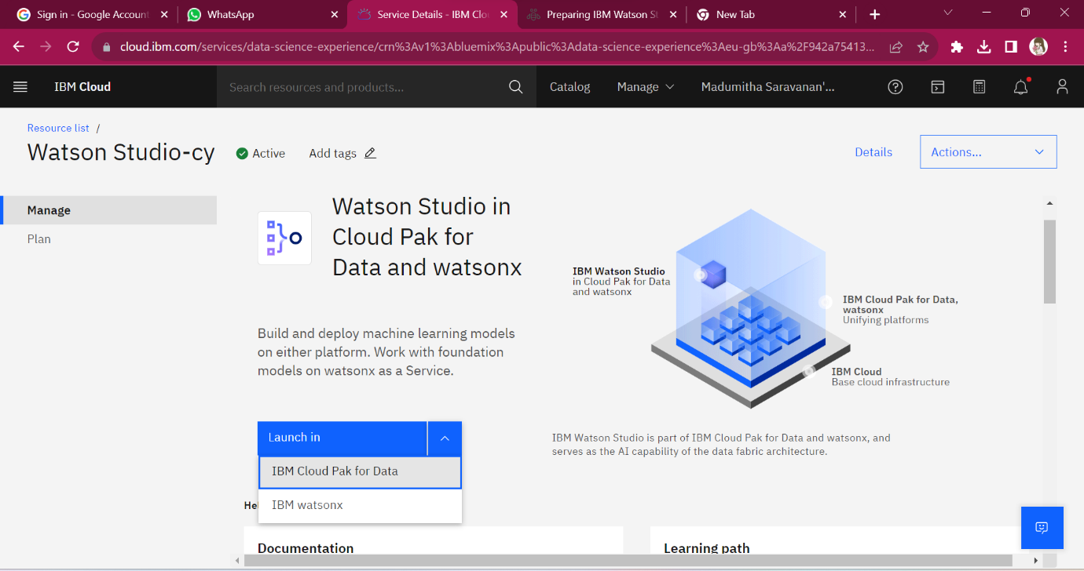

Step 4:

* After launching the IBM Cloud Pak for Data, it displays the below page then press the create new project
* It ask press next for the further process by press next it creates new project

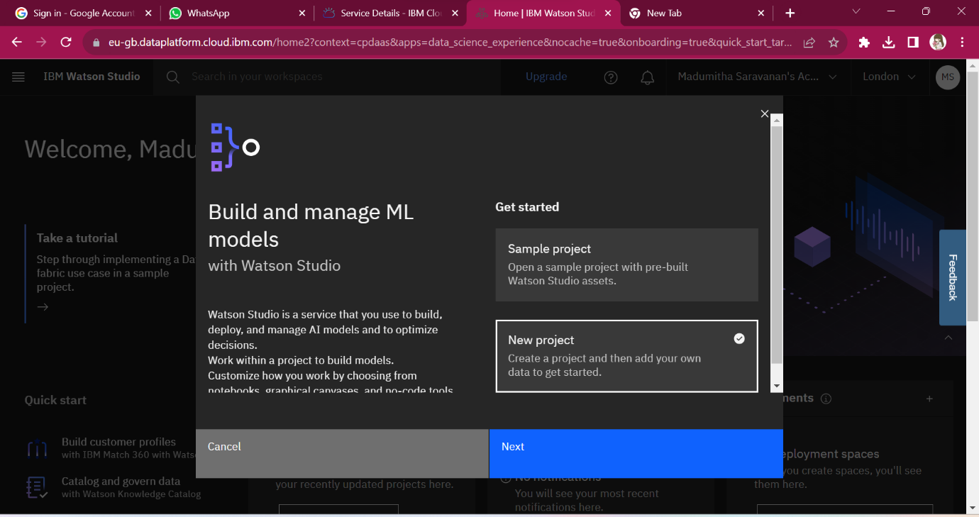

Step 5:

* It asks the project Name & Description to create a project, provide those to create a project

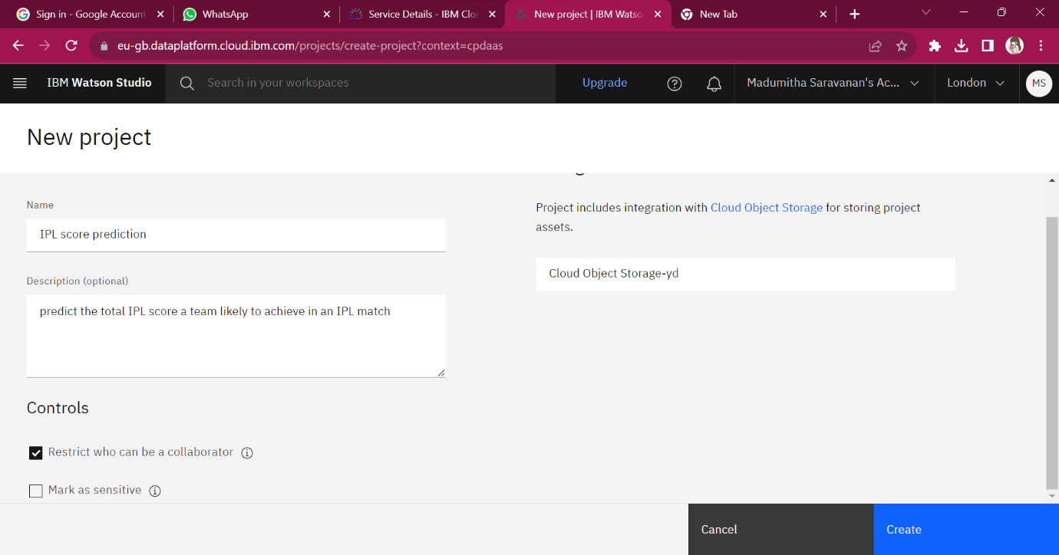

Step 6:

* By pressing create option the new project is created with the Machine Learning Model
* It displays the below page for the further process

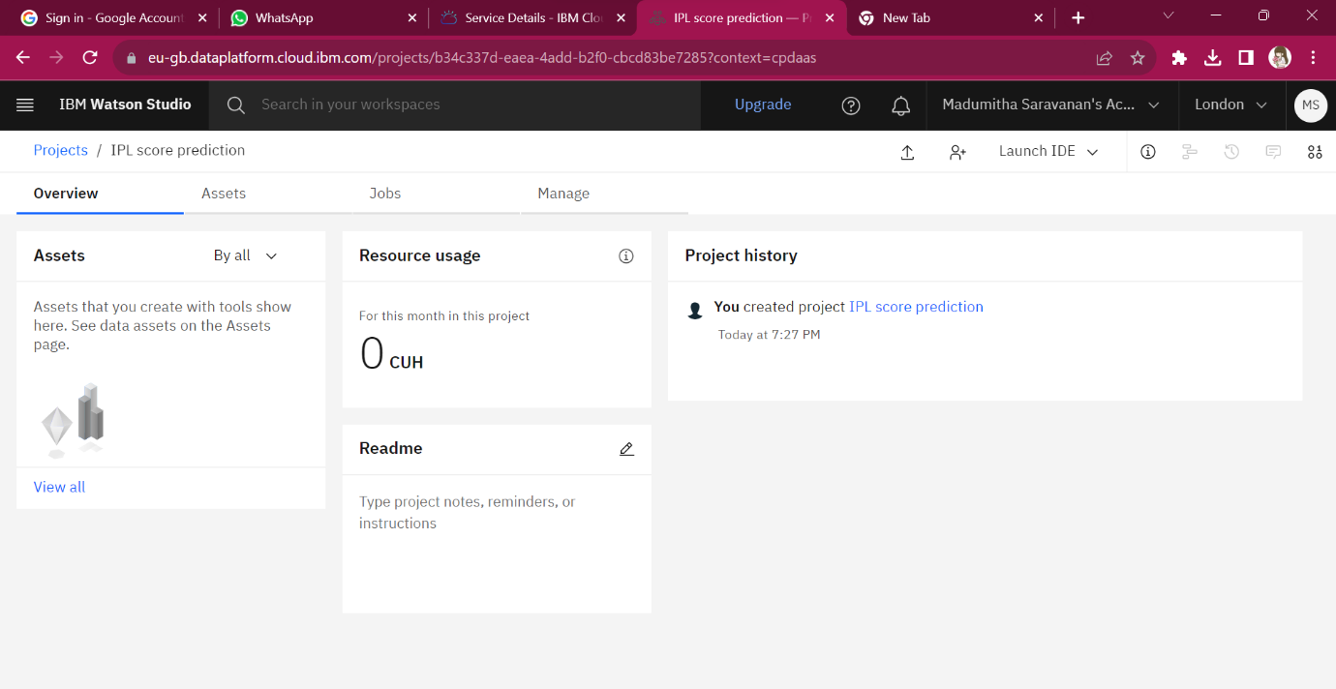

Step 7:

* From above go to the Assets then add the data set in the Assets section

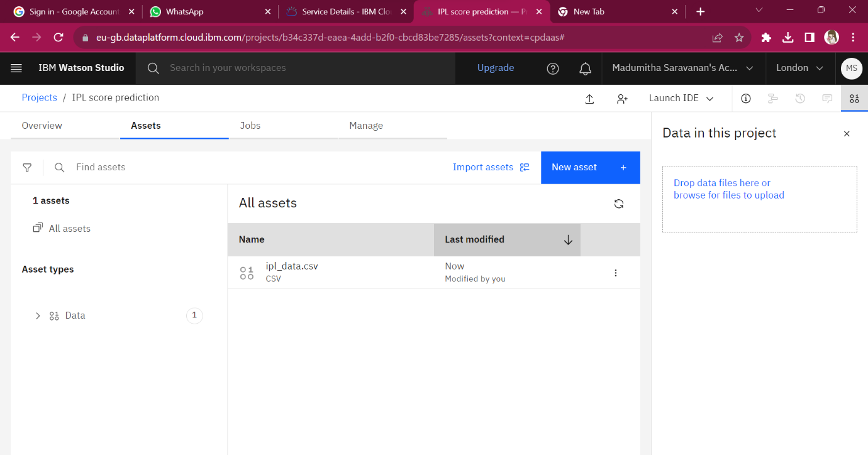

Step 8:

* Press the add Assets then it displays the Data present in the Assets

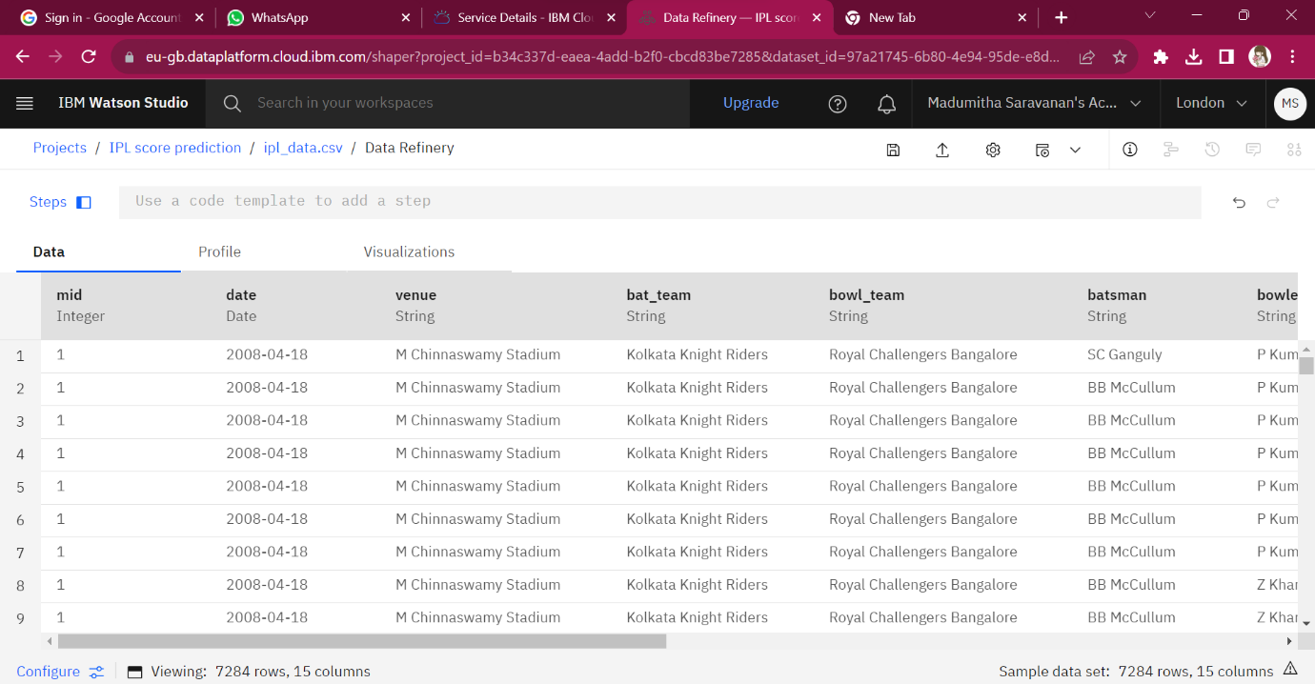

Step 9:

* Press the visualization to visualize the data set present in the Assets.
* In this visualization we see data in the various types of charts
* As of now I am displaying the data in the from of Bar graph

